# **Architecture Design**

# **Investment Analytics**

# **FDI in INDIA**

|  |  |
| --- | --- |
| **Written by** | **AMIT KUMAR** |
| **Document Version** | **0.3** |
| **Last Revised Date** | **28th August 2021** |

# **Contents**

1. Introduction........................................................................................................................ 03

1.1 What is Architecture Design Document? .......................................................... 03

1.2 Scope ..................................................................................................................... 03

2. Architecture ....................................................................................................................... 04

2.1 Power Bi Architecture ........................................................................................... 05

2.2 Power Bi Server Architecture................................................................................ 06

2.3 Comparing Power BI Report Server……………………………………………………………………07

2.4 Licensing Power BI Report Server……………………………………………………………………….08

3. Deployment Description……………………………………………………………………………………..08

3.1 Publish datasets and reports from Power BI Desktop………………………………………….09

3.2 Introduction to deployment pipelines………………………………………………………………..10

3.3 Deploying content to an empty stage………………………………………………………………….12

# **1. Introduction**

# **1.1 What is Architecture design document?**

Any software needs the architectural design to represents the design of software. IEEE defines

architectural design as “the process of defining a collection of hardware and software

components and their interfaces to establish the framework for the development of a computer

system.” The software that is built for computer-based systems can exhibit one of these many

architectures.

# **Each style will describe a system category that consists of :**

• A set of components (eg: a database, computational modules) that will perform a function

required by the system.

• The set of connectors will help in coordination, communication, and cooperation between

the components.

• Conditions that how components can be integrated to form the system.

• Semantic models that help the designer to understand the overall properties of the

system.

# **1.2 Scope**

Architecture Design Document (ADD) is an architecture design process that follows a step-by-step

refinement process. The process can be used for designing data structures, required software

architecture, source code and ultimately, performance algorithms. Overall, the design principles may be defined during requirement analysis and then refined during architectural design work.

# **2. Architecture**

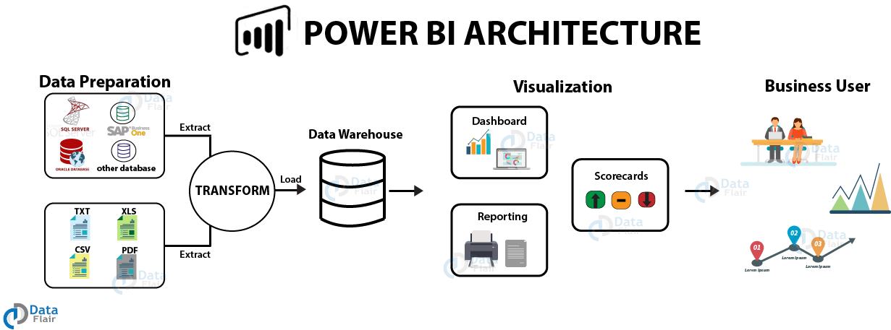

Power BI architecture is a service built on top of Azure. There are multiple data sources that Power BI can connect to. Power BI Desktop allows you to create reports and data visualizations on the dataset. Power BI gateway is connected to on-premise data sources to get continuous data for reporting and analytics. Power BI services refer to the cloud services that are used to publish Power BI reports and data visualizations. Using Power BI mobile apps, you can stay connected to their data from anywhere. Power BI apps are available for Windows, iOS, and Android platforms.

The different components of Power BI are meant to let users create and share business insights in a way that fits with their role.

Included within Power BI are several components that help users create and share data reports.

* **Power Query:**a data mashup and transformation tool
* **Power Pivot:** a memory tabular data modeling tool
* **Power View:**a data visualization tool
* **Power Map:** a 3D geospatial data visualization tool
* **Power Q&A:** A natural language question and answering engine

Additionally, there are dozens of data sources that connect into Power BI, ranging from files (Excel, PDF, SharePoint Folder, XML), databases (SQL Server Database, Oracle Database, IBM databases, Amazon Redshift, Google BigQuery), other Power BI data sets, Azure data connections and many online services (Dynamics 365, Salesforce Reports, Google Analytics, Adobe Analytics, Facebook and others).

# **2.2Power Bi report server**

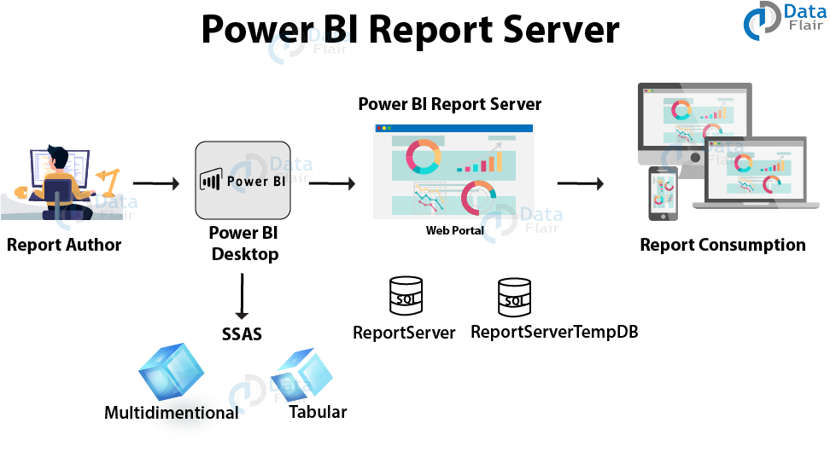

Power BI Report Server is an on-premises report server with a web portal in which you display and manage reports and KPIs. Along with it come the tools to create Power BI reports, paginated reports, mobile reports, and KPIs. Your users can access those reports in different ways: viewing them in a web browser or mobile device, or as an email in their in-box.

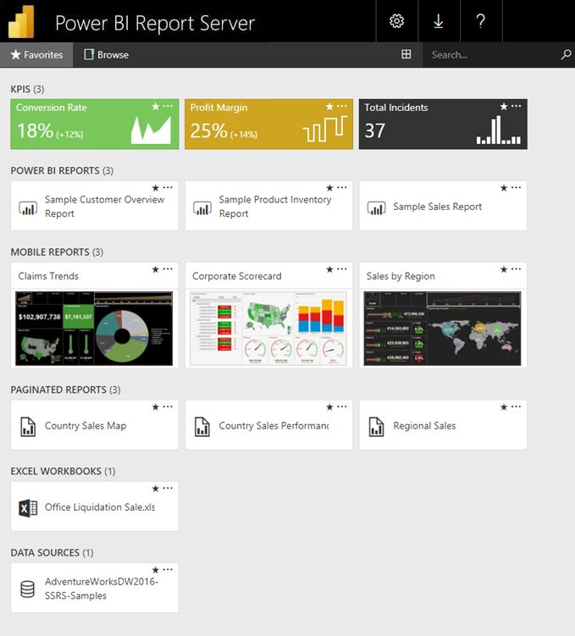

# **2.3Comparing Power BI Report Server**

Power BI Report Server is similar to both SQL Server Reporting Services and the Power BI online service, but in different ways. Like the Power BI service, Power BI Report Server hosts Power BI reports (.pbix), Excel files, and paginated reports (.rdl). Like Reporting Services, Power BI Report Server is on premises. Power BI Report Server features are a superset of Reporting Services: everything you can do in Reporting Services, you can do with Power BI Report Server, along with support for Power BI reports. See [Comparing Power BI Report Server and the Power BI service](https://docs.microsoft.com/en-us/power-bi/report-server/compare-report-server-service) for details.

# **2.4Licensing Power BI Report Server**

Power BI Report Server is available through two different licenses: [Power BI Premium](https://docs.microsoft.com/en-us/power-bi/admin/service-premium-what-is) and SQL Server Enterprise Edition with Software Assurance. See [Microsoft Volume Licensing](https://www.microsoftvolumelicensing.com/DocumentSearch.aspx?Mode=3&DocumentTypeId=1&ShowArchived=True) for details. With a Power BI Premium license, you can create a hybrid deployment mixing cloud and on-premises.

If you publish Power BI reports to Power BI Report Server, you also need a Power BI Pro license. You don't need a Power BI Pro license to view and interact with Power BI reports on Power BI Report Server.

# **3. Deployment Description**

Deployment pipelines enable creators to develop and test Power BI content in the Power BI service, before the content is consumed by users. The content types include reports, paginated reports, dashboards, and datasets. The tool is designed as a pipeline with three stages: Development.

# **Deployment process**

In Power BI Desktop, choose File > Publish > Publish to Power BI or select Publish on the ribbon. Sign in to Power BI, if you aren't already signed in. Select the destination. You can search your list of available workspaces to find the workspace into which you want to publish.

# **3.1 Publish datasets and reports from Power BI Desktop**

When you publish a Power BI Desktop file to the Power BI service, you publish the data in the model to your Power BI workspace. The same is true for any reports you created

in **Report**view. You’ll see a new dataset with the same name, and any reports in your Workspace navigator.

Publishing from Power BI Desktop has the same effect as using **Get Data** in Power BI to connect to and upload a Power BI Desktop file.

# **To publish a Power BI Desktop dataset and reports**

1. In Power BI Desktop, choose **File > Publish > Publish to Power BI** or select **Publish**on the ribbon.

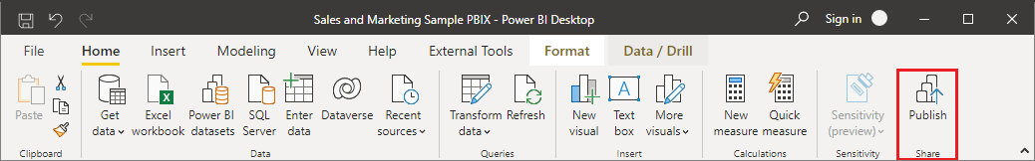

2.Sign in to Power BI, if you aren't already signed in.

3.Select the destination. You can search your list of available workspaces to find the workspace into which you want to publish. The search box lets you filter your workspaces. Select the workspace, and then click the Select button to publish.

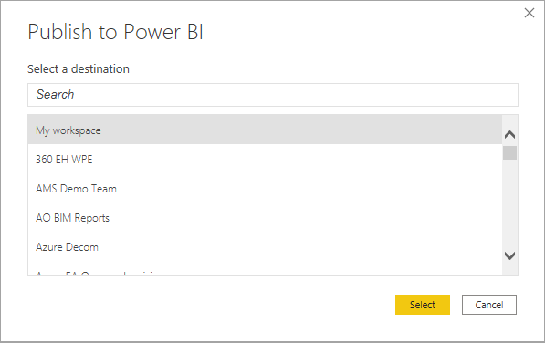

When publishing is complete, you receive a link to your report. Select the link to open the report in your Power BI site.

# **3.2 Introduction to deployment pipelines**

In today’s world, analytics is a vital part of decision making in almost every organization. The growing use of Power BI as an analytics tool, requires it to use more data, look appealing and be user-friendly. Above all however, Power BI needs to always be available and reliable. To meet these requirements, BI creators must collaborate effectively.

The deployment pipelines tool enables BI creators to manage the lifecycle of organizational content. It's an efficient and reusable tool for creators in an enterprise with Premium capacity. Deployment pipelines enable creators to develop and test Power BI content in the Power BI service, before the content is consumed by users. The content types include reports, paginated reports, dashboards, and datasets.

The tool is designed as a pipeline with three stages:

* **Development**

This stage is used to design, build, and upload new content with fellow creators. This is the first stage in deployment pipelines.

* **Test**

You're ready to enter the test stage after you've made all the needed changes to your content. You upload the modified content so it can be moved to this test stage. Here are three examples of what can be done in the test environment:

* + Share content with testers and reviewers
  + Load and run tests with larger volumes of data
  + Test your app to see how it will look for your end users
* **Production**

After testing the content, use the production stage to share the final version of your content with business users across the organization.

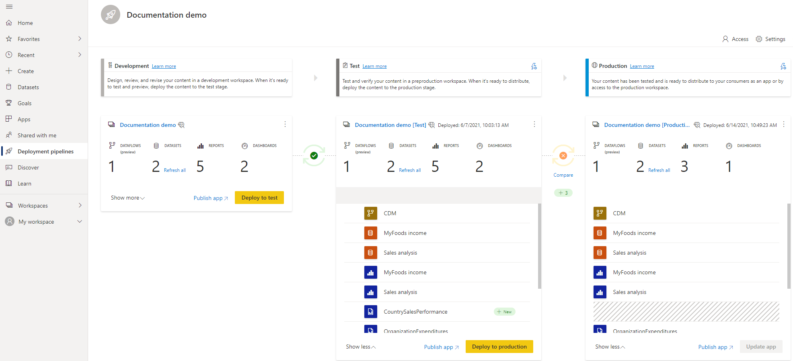

# **The deployment process**

The deployment process lets you clone content from one stage in the pipeline to another, typically from development to test, and from test to production.

During deployment, Power BI copies the content from the current stage, into the target one. The connections between the copied items are kept during the copy process. Power BI also applies the configured deployment rules to the updated content in the target stage. Deploying content may take a while, depending on the number of items being deployed. During this time, you can navigate to other pages in the Power BI portal, but you cannot use the content in the target stage.

You can also deploy content programmatically, using the [deployment pipelines REST APIs](https://docs.microsoft.com/en-us/rest/api/power-bi/pipelines). You can learn more about this process in the [Automate your deployment pipeline using APIs and DevOps](https://docs.microsoft.com/en-us/power-bi/create-reports/deployment-pipelines-automation) article.

# **3.3 Deploying content to an empty stage**

When you deploy content to an empty stage, the metadata of the reports, dashboards, and datasets in the workspace you're deploying from, is copied to the stage you're deploying to. A new workspace for the stage you deployed to, is created on a Premium capacity.

There are two ways to deploy content from one stage to the next one. You can deploy all the content, or you can [select which content items to deploy](https://docs.microsoft.com/en-us/power-bi/create-reports/deployment-pipelines-get-started#selective-deployment).

You can also deploy content backwards, from a later stage in the deployment pipeline, to an earlier one.

After the deployment is complete, refresh the datasets so that you can use the newly copied content. The dataset refresh is required because data isn't copied from one stage to another. To understand which item properties are copied during the deployment process, and which item properties are not copied, review the [item properties copied during deployment](https://docs.microsoft.com/en-us/power-bi/create-reports/deployment-pipelines-process#item-properties-copied-during-deployment) section.